AN Code Review Process

# Guideline

1. The following AN JIRA tickets need compulsive code review before pushing to testing:
   1. New Feature
   2. Bug
   3. Subtask – Bug PreRelease (ER bugs)
   4. ESI
2. Peer code review is used in AN – when a developer completed an implementation/fixing another developer does the code review. Crucible is used for peer code review.
3. For very sensitive issues (like hotfix, core functions) team review is required. DEV Manager books the review meeting with proper developers (more than 2) to review with the implementer together
4. Code reviewer must add comment on JIRA ticket to indicate code review is done.

# Review Content

## New Feature

1. Check whether the coding implemented the design requirement correctly
2. Check whether the coding missed any requirement
3. Check whether there are any potential coding error
4. Check whether the coding meet the performance requirement (will not cause potential performance issue)
5. Check and make sure the coding will not break other functionalities
6. Check whether the coding is based on a best practice
7. Check if the implementer provided the RCA/Change impact area etc on JIRA

## Bug / Subtask – Bug PreRelease (ER bugs)

1. Check whether the coding fixed the bug
2. Check whether there are any potential coding error
3. Check whether the coding meet the performance requirement (will not cause potential performance issue)
4. Check and make sure the coding will not break other functionalities (will not cause new bugs)
5. Check whether the coding is based on a best practice
6. Check if the implementer provided the RCA/Change impact area etc
7. Check if the implementer selected the correct “Defect Origin” & “Defect Created By”

## ESI (for Data Fixing)

1. Check whether the script fixed the data correctly and entirely
2. Check and make sure the fixing will not impact other data
3. Check if the implementer provided the roll back script

# Process

## New Feature

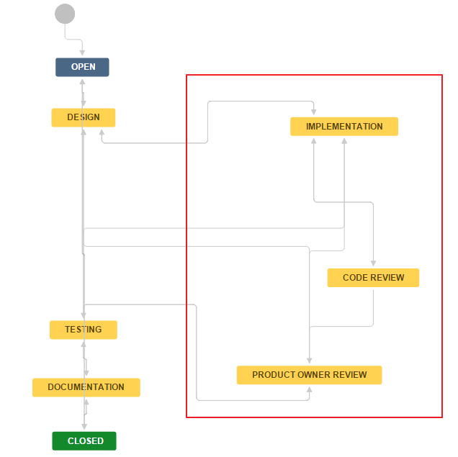

## Bug / Subtask – Bug PreRelease (ER bugs)

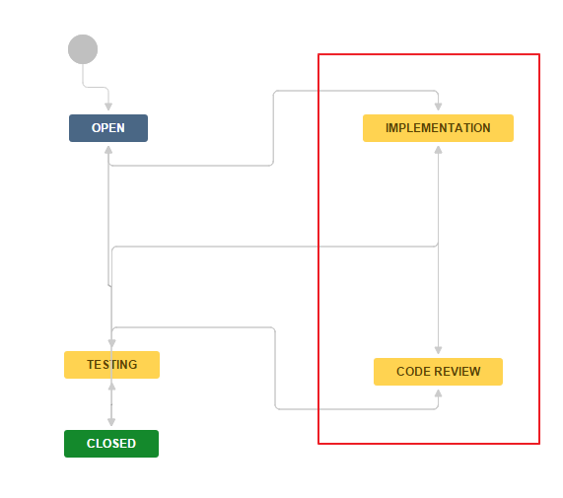

## ESI

